 

**Placement Empowerment Program**

***Cloud Computing and DevOps Centre***

Set Up a Virtual Machine in Cloud Create a Free Tier AWS Account and SSH into it

Name: Vijaya Nandana M Department: CSE



**Introduction**

This PoC explores about Virtual Machines on Cloud and How to connect into it using SSH. A Virtual Machine/Instance is a crucial component in Cloud computing, which acts as a major key factor of aws cloud. Here, we are creating an EC2 Instance through the management console and connecting to the instance using SSH keys in Cmd.

**Step-by-Step Overview**

Step 1

Log into your AWS Management Console or Create a New Free Tier account if not.

Step 2

Go to the Search bar and search the service “EC2”

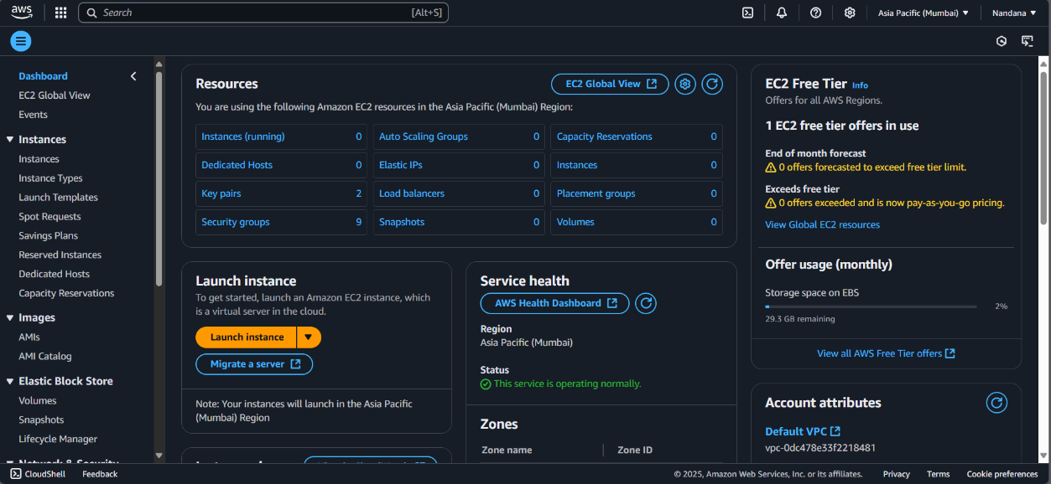

Step 3

* Choose Amazon Linux 2023 Free Tier AMI or Ubuntu Free Tier AMI.
* Select the t2.micro instance type (free tier).
* Configure security group: Allow SSH (Port 22) from your IP.
* Add a key pair: If you don’t have one, create a new key pair and download it as a .pem file.
* Click Launch Instance.

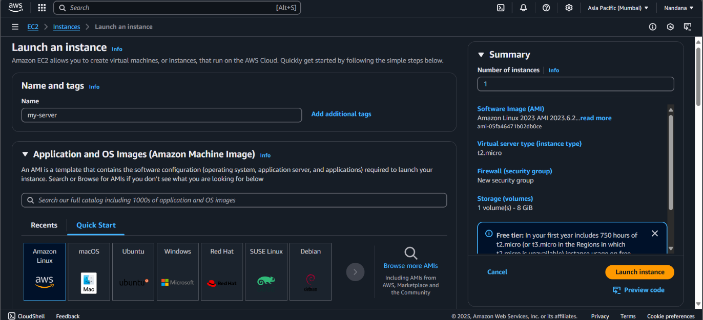

Step 4

* Select your Instance and click the Connect Option.
* Go to the SSH client section and Copy the Link shown

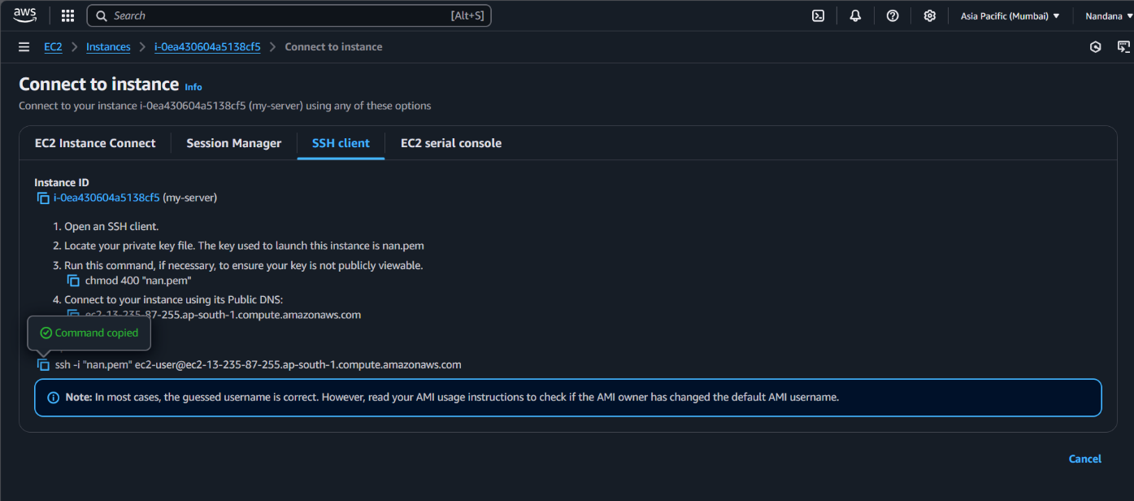

Step 5

Open PowerShell, navigate to the Downloads folder.

Run the SSH command from the EC2 Connect section, replace the key name with your downloaded key (e.g., new.pem), press Enter, and type yes when prompted.

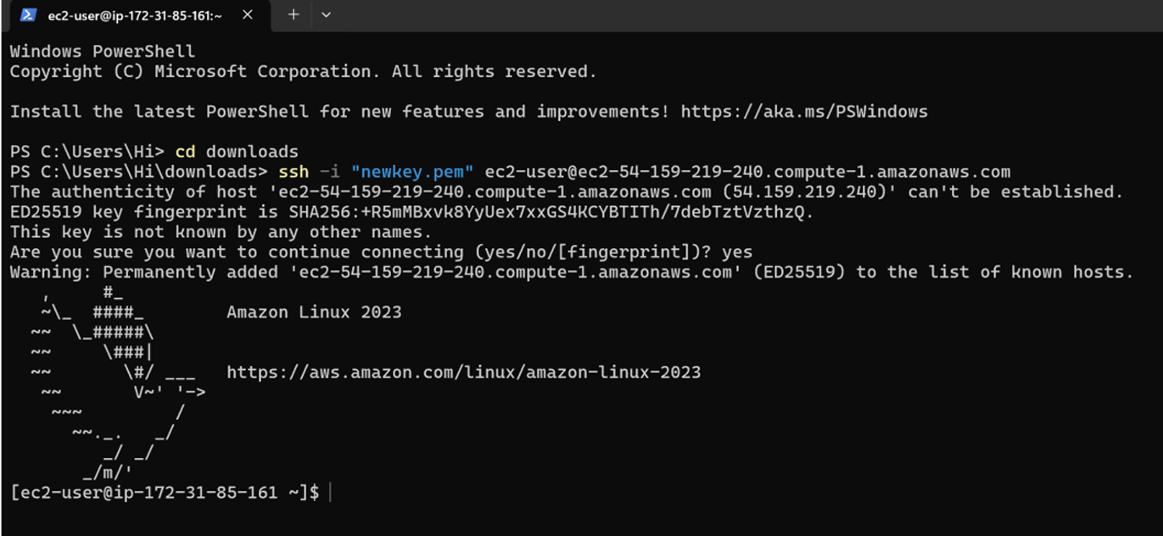

**Outcome:**

Through this PoC we have successfully learnt how to launch a Virtual Machine/ EC2 Instance in Cloud and Connect it through SSH keys.